Install sonar scanner plugin

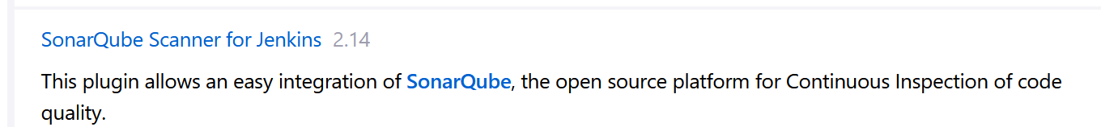

Create Project in Sonarqube and copy the token.

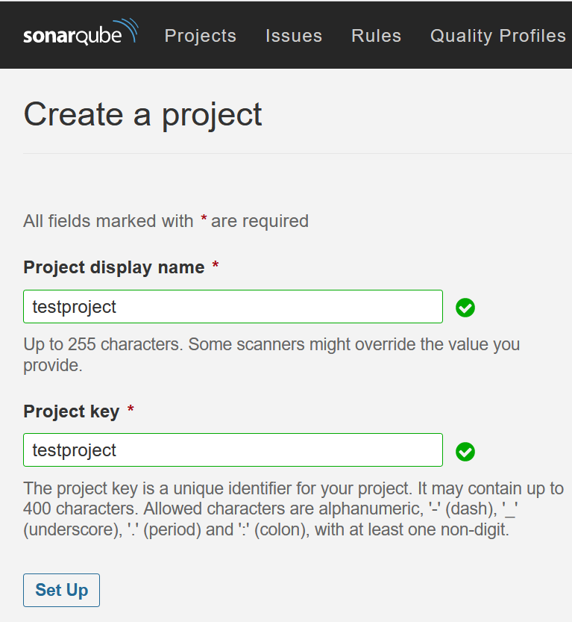

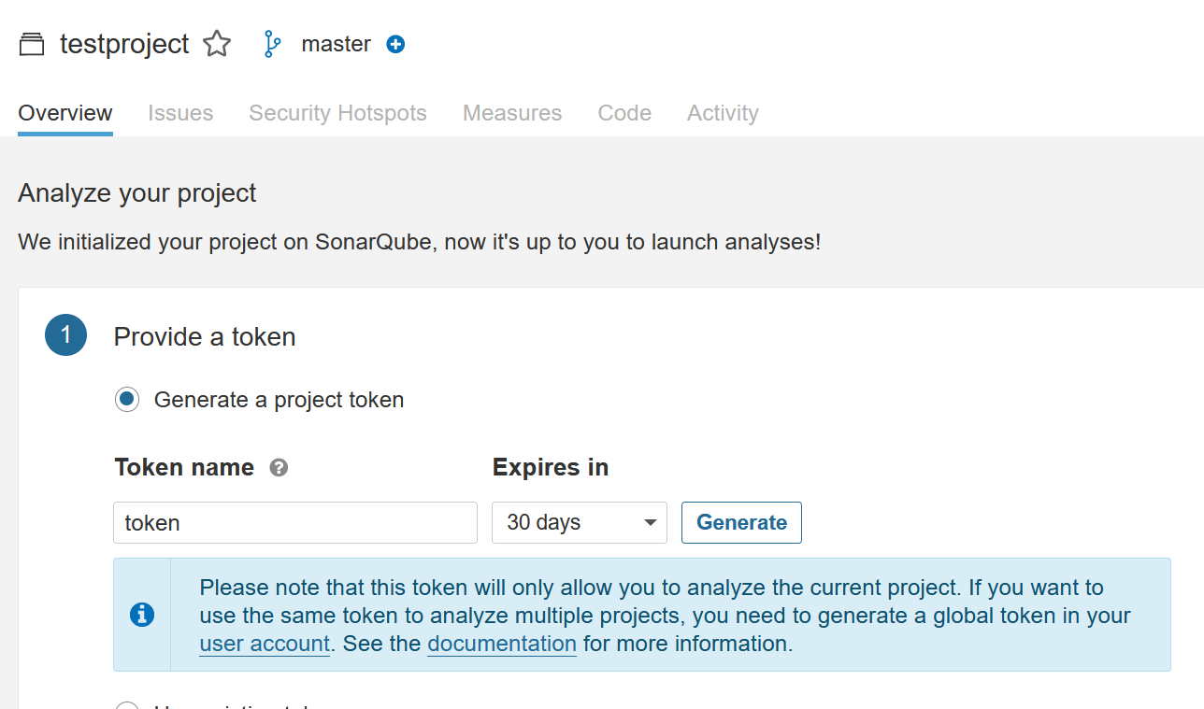

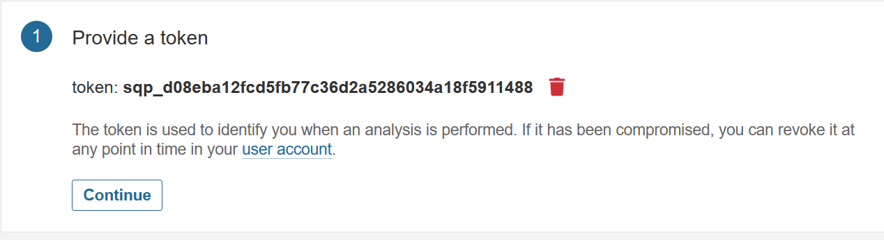

Create a Credential with Secret Text from the token above step:

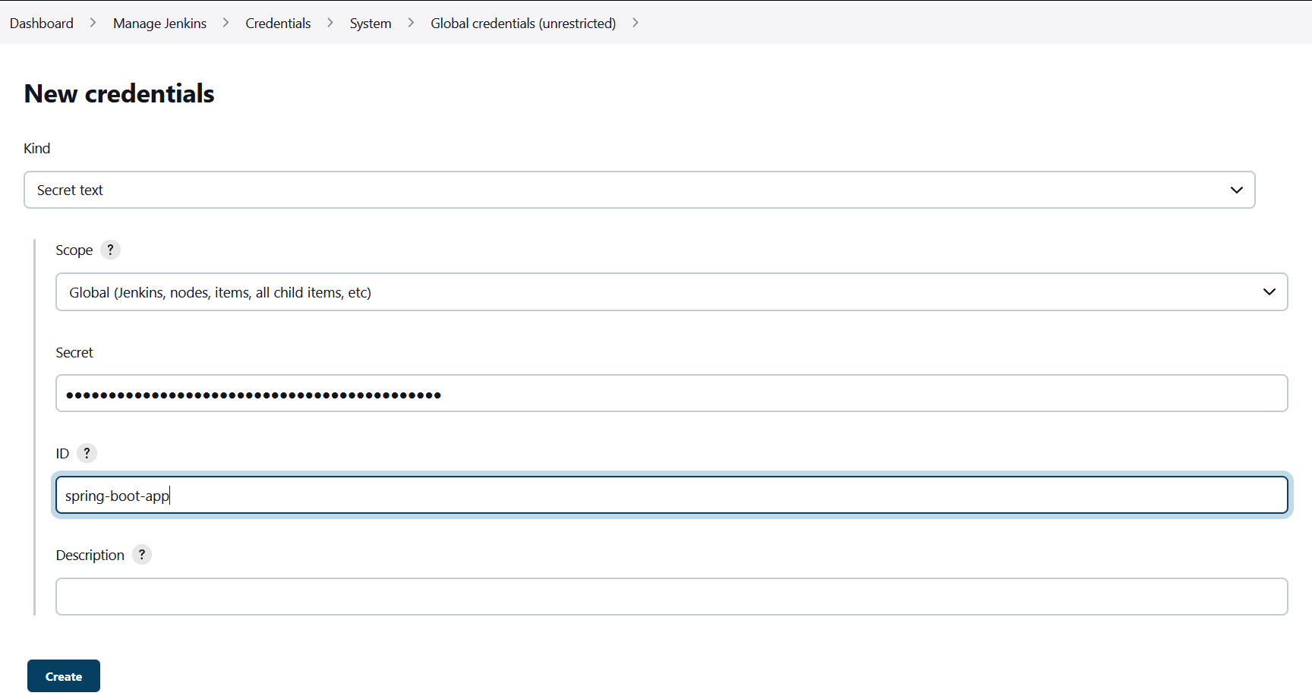

Configure SonarQube Server:

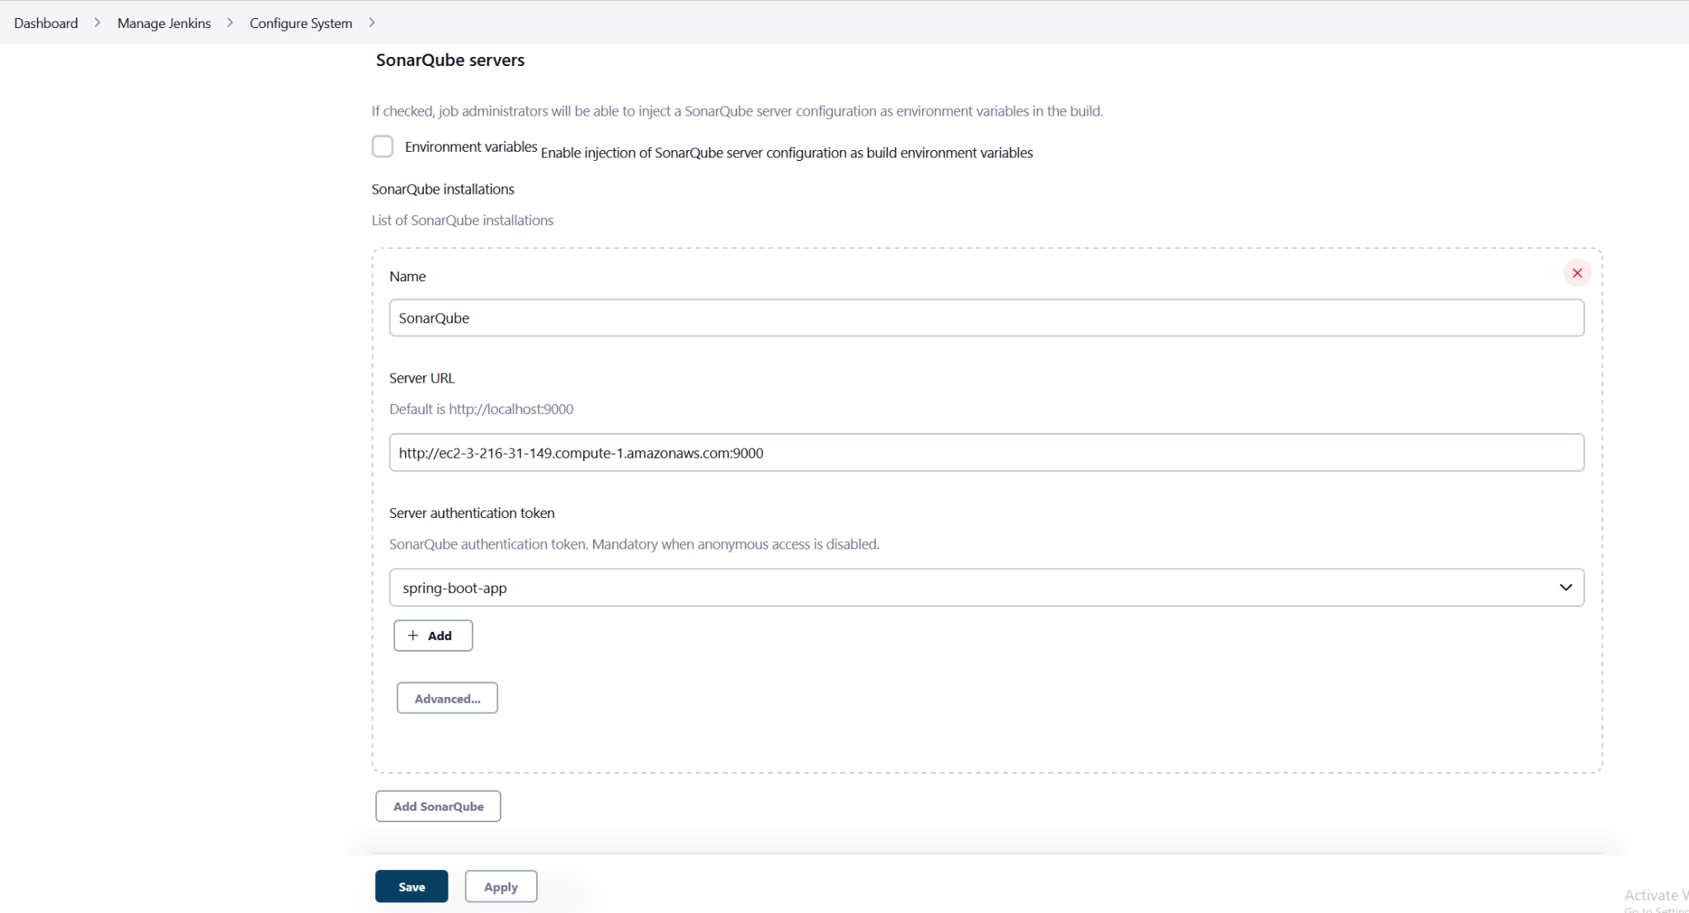

Configure Webhooks in Sonarqube Server:

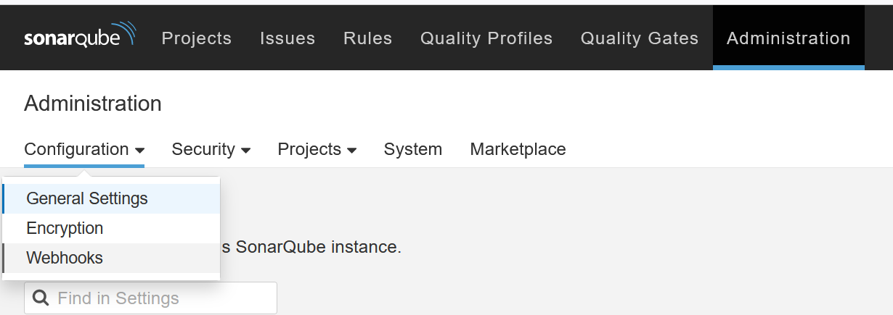

http://<Jenkins-public-IPAddress>:8080/sonarqube-webhook/

